**HR Management**

**System Design**

**Supervisor:** Dr. Mohammad Taye.

**Students Name**: Wesam Da’abes

Fahed Khalil

Malik Qawasmeh

**Table of Contents:**

**CH1: Proposal**

**1.1 Goals and Objectives**

**....................................................................................................................................... 5**

**1.2 Brief description of the project**

**....................................................................................................................................... 5**

**1.3 References**

**....................................................................................................................................... 5**

**1.4 Prerequisite**

**....................................................................................................................................... 6**

**1.5 Project Specialization**

**....................................................................................................................................... 6**

**1.6 Title**

**....................................................................................................................................... 6**

**1.7 Introduction**

**....................................................................................................................................... 6**

**1.8 Objective**

**....................................................................................................................................... 6**

**1.9 Problem Statement**

**....................................................................................................................................... 6**

**1.10 Motivation**

**....................................................................................................................................... 7**

**1.11 Literature Review**

**....................................................................................................................................... 7**

**CH2: Requirement Engineering Part**

**2.1 Domain Understanding**

**....................................................................................................................................... 9**

**2.1.1 Context**

**....................................................................................................................................... 9**

**2.1.2 Scope of the systems as-is**

**....................................................................................................................................... 9**

**2.1.3 Stakeholders**

**....................................................................................................................................... 9**

**2.1.4 Strengths and Weaknesses of the system as-is**

**....................................................................................................................................... 9**

**2.1.5 Glossary of Terms**

**....................................................................................................................................... 9**

**2.2 Requirement Elicitation**

**....................................................................................................................................... 9**

**2.2.1 Requirement Specification**

**....................................................................................................................................... 13**

**2.2.2 Requirements Analysis**

**....................................................................................................................................... 15**

**2.2.3 Requirements Validation**

**....................................................................................................................................... 15**

**2.2.4 Requirement Modeling**

**....................................................................................................................................... 16**

**CH3: Software Requirements Specification**

**3.1 Introduction**

**....................................................................................................................................... 18**

**3.1.1 Purpose**

**....................................................................................................................................... 18**

**3.1.2 Scope**

**....................................................................................................................................... 18**

**3.1.3 Definitions, acronyms and abbreviations**

**....................................................................................................................................... 19**

**3.1.4 References**

**....................................................................................................................................... 19**

**3.2 Overview**

**....................................................................................................................................... 19**

**3.2.1 Overall description**

**....................................................................................................................................... 20**

**3.2.2 User characteristics**

**....................................................................................................................................... 20**

**3.2.3 Product prespictive**

**....................................................................................................................................... 21**

**3.2.4 Product functions**

**.................................................................................................................................... 22**

**3.2.5 Constraints**

**....................................................................................................................................... 22**

**3.2.6 Assumptions and dependencies**

**....................................................................................................................................... 22**

**3.2.7 Apportioning of requirements**

**....................................................................................................................................... 22**

**3.3 Functional Requirements**

**....................................................................................................................................... 22**

**3.4 Non- Functional Requirements**

**....................................................................................................................................... 26**

**3.5 User interfaces**

**....................................................................................................................................... 27**

**3.5.1 Software interface**

**....................................................................................................................................... 32**

**3.5.2 Communication interface**

**....................................................................................................................................... 32**

**3.6 Software system attributes**

**....................................................................................................................................... 33**

**CH4: Software Architecture**

**4.1 Introduction**

**....................................................................................................................................... 33**

**4.2 Benefits Of Software Architecture**

**....................................................................................................................................... 34**

**4.3 Importance Of Software Architecture**

**....................................................................................................................................... 34**

**4.4 Selected technology**

**....................................................................................................................................... 35**

**Chapter 1: Proposal**

**1.1 Goals and Objectives**

1) Usability and efficiency of employees services

2) Generate reports of employee leaves or vacation and complaints

3) To calculate the employee salary

**1.2 Brief description of the project**

The HR Management system is one of the most important systems that must be available in every company because it will save time and effort to complete some simple transactions. Job description is the completion of some transactions online, the most important of which is (requesting a vacation, submitting a complaint to the manager or knowing the employee’s daily working schedule, through which or Inquire about the date of receiving the salary and its value. And each employee can registration with employee id and password.

**1.3 References** **:1)**

**IEEE Citation Style Guide**

**World Wide Web**

A.projects*. “Title.” Web student portal for the it and management : www.freeprojectz.com, Nov.7,2014* [March.10,3,2021].

**Lecture**

M. Tayee. Dr. final project, Topic: “discussing.” ICT 224, Faculty of IT, University of Philadelphia, Jordan, Amman, April. 31, 2021.

**E-mail**

W.daabes “new message ,done?wesamdaabes98@gmail.com ”. (April.3,2021).

**Project Requirements (Hardware & Software)**

.**-**

**Company** **or organization (If applicable)**   
not applicable

**1.4 Prerequisite**   
 Completion of 90 study hours

**1.5 Project Specialization (Software Engineering)**Software Engineering

**1.6 Title** **:** HR Management system

**1.7 Introduction:**

The proposed project "HR Management System" has been developed to overcome the problems faced in the practicing of manual system. This software is built to eliminate and in some cases reduce the hardships faced by the existing system. Moreover this system is designed for particular need of the company to carry out its operations in a smooth and effective manner.

It is a special system for employees in any company in which basic jobs are available for any employee, such as (vacations - working hours - employee or manager notes within work - and salary inquiries).

**1.8 Objective:**

1) Useability and efficiency of employees services.

2) Generate reports of employee leaves or vacation and complaints.

3) To calculate the employee salary.

**1.9 Problem Statement:**

Overcoming the problems facing the manual system and creating transactions electronically to make it easier for employees and management to communicate between them .

**1.10 Motivation:**

The motivation of the project is to provide employee services in a simple and fair way for business operations to run smoothly. Leave requests management also handle staffing requirements with ongoing policy and legal compliance.

**1.11 Literature Review:**

**sagar informatics**

### HR software to retain and develop employees, drive engagement, optimize benefits, and increase productivity.

sagar Informatics is HR software that features a record of assigned tasks, employee data analysis, employee monitoring, a centralized employee database, worksheet and timesheet management, and time-off tracking.

This software has a good track record of after-sales support and other customer service resources. Issues are dealt with promptly by email or phone and they have multiple numbers at which they can be reached.

### Sap SuccessFactors

### HR software to retain and develop employees, drive engagement, optimize benefits, and increase productivity.

### Sap SuccessFactor is an engagement-focus HR tool that offers flexible employee surveys, role-based dashboards and reporting, customizable impact reports, event-based triggers, and employee rewards programs.

**Methodology:**

Waterfall model because requirement are very well known , product definition is stable

Technology is understood . easy to use , quality is more important than cost or schedule .

**Chapter 2: Requirement Engineering Part**

**Requirement Engineering Part:**

**2.1 Domain Understanding:**

HR Management System is a website used to complete some simple transactions using the Internet instead of the paper-based system. The site provides the following services: 1) Request leave or submit a complaint to the manager 2) The daily work schedule in addition to the number of additional hours desired by the employee 3) Inquire about the salary and its value this month 4) Each employee can register with the employee's identification number and password.

**2.1.1 Context:**

The system as is takes place of paper based system and it’s objectives. But the website saves Time, Effort and Useability .

**2.1.2 Scope of the systems as-is:**

This project is beneficial for companies in maintaining employee record. Salary calculation for each employee and also focus on attendance of each employee and the number of leaves taken per month / year. There is also the possibility to check the salary report at any time so as not to lead to any miscalculation.

* + 1. **Stakeholders:**

|  |  |
| --- | --- |
| Actor | Interests |
| Managing Director | Salary, Working hours, Job security,  Managing vacation request and reports. |
| Employees | Salary, Working hours, Job security, Vacation request or reports. |
| Company Owners | Business operations to run smoothly, Profit. |
| IT Developer | Create the website, Level of security, Privacy, Data Storage. |

**2.1.4 Strengths and Weaknesses of the system as-is**

The Strength Of Paper System Is :

Documentation.

The Weaknesses Of Paper System Is :

1. Prone to damage: Manual documents can be easily damaged, lost, or stolen.
2. Higher costs: Because we will need more paper, printers, copiers, stationery and other office supplies.
3. Lack of security: Paper is one of the biggest information security risks for companies because printed documents can easily be lost, mishandled, or destroyed while digital data can be encrypted and kept securely in hard disks or electronic devices.
   * 1. **Glossary of Terms:**

|  |  |  |
| --- | --- | --- |
| **1** | EIN | Employee Identification Number |
| **2** | HRMS | Human Resource Management System |
| **3** | LMS | Leave Management System |
| **4** | OP | Overtime Pay |

**2.2 Requirement Elicitation**

*1.*  **Retained Requirement elicitation techniques**

**-** *Which ones?* Questionnaire

*- Motivations?* we can't meet the employee in this time cause of corona virus

For easy access to a larger number of employees and for accurate reports and Asking the employee easily than making and save time also

*2.* **Requirement Elicitations Document**

**2.2.1 Requirement Specifications**

**2.2 Software Requirements**

**2.2.1 Functional Requirements**

**Admin:**

|  |  |
| --- | --- |
| Functional | Description |
| Login | Log in using the administrator number and password |
| Change password | The password change or restore |
| Add new employee | The Admin can add a new employee |
| Add attendance dates for employees | The Admin can add working time for employees |
| Accept or reject holiday or leave | The Admin can approve or deny a holidays or leave To the employee with the reason written |
| Calculate the salary | The Admin can Calculate the salary To the employee |
| view employee review | The Admin can view and respond to employee feedback |

**Employee:**

|  |  |
| --- | --- |
| Functional | Description |
| login | Log in using the employee number and password |
| Change password | The password change or restore |
| Request holiday or leave | Employees are allowed to request holiday or leave |
| Writ a complaint or a note to the director | Employees are allowed to submit a complaint or note to the manager |
| view work time | Employees are allowed to view working hours |
| view the salary | Employees are allowed to view the salary amount |
| Admin reviews | It allows employees to view the manager's notes |

**Non Functional Requirements**

Usability: the system is easy to use by the users, we tried to provide easy control interfaces in the design.

**2.2.2 Requirements Analysis**

The requirement was read and it was clear and understandable and there is no ambiguity in it and it was easy to apply and it was dealt together with all transparency

**2.2.3 Requirements Validation**

|  |  |  |  |
| --- | --- | --- | --- |
|  | **Question** | **Yes** | **No** |
| **1** | Does it possible to implement all of the requirements? | Yes |  |
| **2** | Is the maintainability of the system/software specified?  Including the ability to respond to changes in the operating environment, interfaces, accuracy, performance, and additional predicted capabilities. |  | No |
| **3** | Have requirements for communication among system/software components been specified? | Yes |  |
| **4** | Have overall function and behavior of the system/software been defined? | Yes |  |
| **5** | Is the maximum memory specified? |  | No |
| **6** | Do the requirements define all the information that is to be displayed to the user? | Yes |  |
| **7** | Are there conflicting requirement? |  | No |
| **8** | Is each requirement testable? | Yes |  |
| **9** | Is the level of security specified? | Yes |  |
| **10** | Have the software and hardware environments been defined? | Yes |  |
| **11** | Are the specified error messages unique and meaningful? | Yes |  |
| **12** | Is each requirement in scope for the project? | Yes |  |

**2.2.4 Requirement Modeling:**

**Use case:**

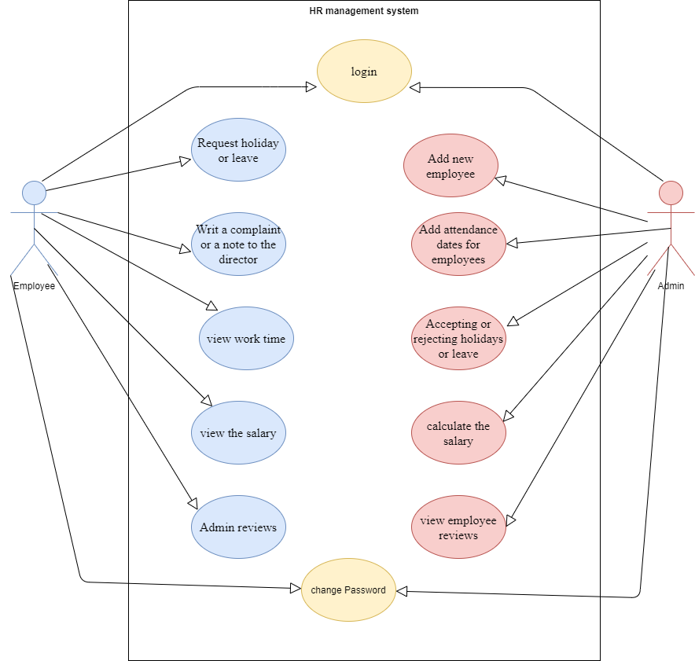

**Figure(1): Use case**

**Class diagram:**

Here will see the class diagram for the HRMS in figure (2). That illustrate a system’s structure in

a detailed way ,showing its attributes ,operations as well as its relations.

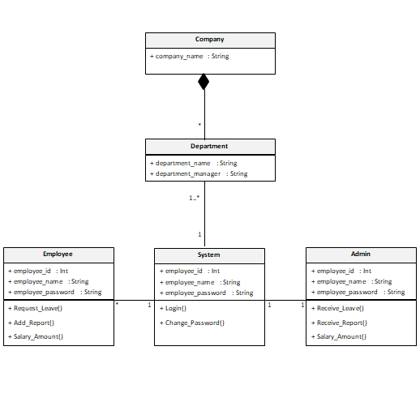

**Figure(2): Class Diagram**

**Chapter 3:Software Requirements Specification**

**3.1 Introduction:**

This document is a Software Requirement Specification (SRS) for the Human Resources Management System (HRMS) Project. We will give a complete description for overview and list the requirements which meet the needs of the company.

**3.1.1 Purpose:**

The purpose of this document is to give a detailed description of the requirements of HR Management System (HRMS). This document is primarily intended to be proposed to overcome the problems faced in the practicing of manual system, reduce the hardships faced by the existing system and to particular need of the company to carry out its operations in a smooth and effective manner.

**3.1.2 Scope:**

HR Management System is a website used to complete some simple transactions using the Internet instead of the paper-based system. The site provides the following services: 1) Request leave or submit a complaint to the manager 2) The daily work schedule in addition to the number of additional hours desired by the employee 3) Inquire about the salary and its value this month 4) Each employee can register with the employee's identification number and password.

This website is beneficial for companies in maintaining employee record. Salary calculation for each employee and also focus on attendance of each employee and the number of leaves taken per month / year. There is also the possibility to check the salary report at any time so as not to lead to any miscalculation.

**3.1.3 Definitions, acronyms and abbreviations:**

|  |  |  |
| --- | --- | --- |
| **1** | SRS | Software Requirements Specification |
| **2** | EIN | Employee Identification Number |
| **3** | HRMS | Human Resource Management System |
| **4** | LMS | Leave Management System |
| **5** | OP | Overtime Pay |
| **6** | Admin / Administrator | Administrator who is given specific permission for managing and  controlling the system |

**3.1.4 References**

**IEEE Citation Style Guide**

**World Wide Web**

A.projects*. “Title.” Web student portal for the it and management: www.freeprojectz.com, Nov.7,2014* [March.10,3,2021].

**Lecture**

M. Tayee. Dr. final project, Topic: “discussing.” ICT 224, Faculty of IT, University of Philadelphia, Jordan, Amman, April. 31, 2021.

**E-mail**

W.daabes “new message ,done?wesamdaabes98@gmail.com ”. (April.3,2021).

**3.2 Overview:**

The remainder of this document includes three chapters and appendixes. The second one provides an overview of the system functionality and system interaction with other systems. This chapter also introduces different types of stakeholders and their interaction with the system. Further, the chapter also mentions the system constraints and assumptions about the product.

The third chapter provides the requirements specification in detailed terms and a description of the different system interfaces. Different specification techniques are used in order to specify the requirements more precisely for different audiences.

The fourth chapter deals with the prioritization of the requirements. It includes a motivation for the chosen prioritization methods and discusses why other alternatives were not chosen. The Appendixes in the end of the document include the all results of the requirement prioritization and a release plan based on them.

**3.2.1 Overall description:**

This section will give an overview of the whole system. The system will be explained in its context to show how the system interacts with other systems and introduce the basic functionality of it. It will also describe what type of stakeholders that will use the system and what functionality is available for each type.

At last, the constraints and assumptions for the system will be presented.

This section does not state specific requirements. Instead it provides a back ground for those requirements, which are defined in section 3, and makes them easier to understand.

**3.2.2 User characteristics:**

There are three types of users that interact with HRMS: Employees, Managing Director/Admin and Company Owners . Each of these three types of users has different use of the system so each of them has their own requirements.

Employees: The website provides the following services for employees: 1) Request leave or submit a complaint/report to the manager 2) The daily work schedule in addition to the number of additional hours desired by the employee 3) Inquire about the salary and its value with OP working this month 4) Each employee can register with the EIN and password.

Managing Director/Admin: Manager is also an employee and his interests in the website will be: Salary, Working hours, Job security. But he has a special validity which is managing vacation request and reports. Which is mean he can accept or reject the vacation request or reports.

Company Owners: The only thing that company owners are interested in the website is profit and business operations to run smoothly.

**3.3.3 Product perspective:**

This system consists of a website. The website will be used to facilitate the process of information exchange between the two parties of the manager and the employee and the completion of transactions for the employees.

The website will need to connect to the internet from any smart device in order to be able to use it. The website will provide the employee with jobs like (vacations - working hours - employee or manager notes within work - and salary inquiries)

The functions provided by the website will be included so that the user can use the functions in the application smoothly Since this is a data-driven product, it will need somewhere to store the data. Therefore, a database will be used. The website will communicate with the database.

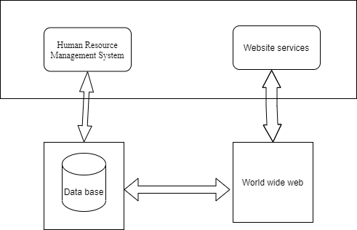

**Figure(1): Product perspective:**

**3.2.4 Product functions:**

Completing some online transactions, the most important of which are (requesting leave, submitting a complaint, sending notes to the manager or receiving them, knowing the employee's daily work schedule or from or calculating the employee's salary.

**3.2.5 Constraints:**

Internet connection is also restricted on the website. Since the website fetches data from the database over the internet, it is vital that there is an internet connection for the website to function.

**3.2.6 Assumptions and dependencies:**

One of the assumptions about the product is that it will always be used on the website accessed from any smart device. For example, users may have customized it with other websites, there may be scenarios where the website does not function as intended or even at all.

**3.2.7 Apportioning of requirements:**

In the case that the project is delayed, there are some requirements that could be transferred to the next version of the website.

**3.3 Functional requirements:**

This section includes the requirements that specify all the main actions of the software system.

**Functional Requirement 1**

**TITLE:** log in

**DESC:** The user must be able to enter the site and choose the employee or manager **RAT**: for the user to use the website

**DEP:** FR1.

**Functional Requirement 2**

**TITLE**:  change Password

**DESC**: The password change or restore

**RAT**: To maintain privacy

**DEP**: None

**ID**: FR3

**TITLE**:  Add new employee

**DESC**: The Admin can add a new employee for the employee to use the website

**RAT**: for the user to use the website

**DEP**: None

**ID**: FR4

**TITLE**: Request holiday or leave

**DESC**: Employees are allowed to request holiday or leave

**RAT**: In order for the employee to complete the transaction

**DEP**: None

**ID**: FR5

**TITLE**: Writing a complaint or a note to the director

**DESC**: Employees are allowed to submit a complaint or note to the manager

**RAT**: In order for the employee to complete the transaction

**DEP**: None

**ID**: FR6

**TITLE**: view work time

**DESC**: Employees are allowed to view working hours

**RAT**: In order for the employee to continue working

**DEP**: None

**ID**: FR7

**TITLE**: view the salary

**DESC**: Employees are allowed to view the salary amount

**RAT**: So that the employee can get the salary

**DEP**: None

**ID**: FR8

**TITLE**:  Admin reviews

**DESC**:It allows employees to view the manager's notes

**RAT**: In order for the employee to complete the transaction

**DEP**: None

**ID**: FR9

**TITLE**:  Add attendance dates for employees

**DESC**: The Admin can add working time for employees

**RAT**: In order for the employee to complete the work

**DEP**: None

**ID**: FR10

**TITLE**:  Accept or reject  holidays or leave

**DESC**: The Admin can approve or deny a holidays or leave To the employee with the reason written

**RAT**: So that employees can get it

**DEP**: None

**ID**: FR11

**TITLE**:  calclate the salary

**DESC**: The Admin can Calculate the salary To the employee

**RAT**: So that employees can get it

**DEP**: None

**ID**: FR12

**TITLE**:  view employee review

**DESC**: The Admin can view and respond to employee feedback

**RAT**: So employees can get feedback

**DEP**: None

**ID**: FR13

**TITLE:** Request a service

**DESC:** The employee must be able to request a service he wants to provide to him by sharing and waiting for a response from the manager.

**RAT**: for the user to request a required service.

**ID:** FR14

**TITLE** **:**Website - Profile Page

**DESC:** On the website, the user must have a profile page. On the profile page, the user can edit their information, which includes password, email address and phone number. The user must also be able to choose which language to understand. The different language options are Arabic and English.

**RAT:** in order for a user to have a profile page on the website.

**3.4 Non-Functional Requirements:**

**ID: QR1**

**TITLE:** Usability

DESC: website should be easy to learn, support speed performance, low error rate and user attitude.

**RAT:** In order for a user to use the system easily

**DEP:** None

**Privacy**

**ID: QR2**

**Title:** Privacy

**DESC:** The website should support information privacy for all users and their record will be private and stored in the servers and will not be available to anyone without the user's permission.

**RAT:** so that the user can use the system without any concerns about his data.

**DEP:** None

Testing  
  
**Functional testing**

|  |  |  |  |  |
| --- | --- | --- | --- | --- |
| Result | Output | Input | Test case | Test case number |
| pass | Login succeeds and home page presented | Valid username and password | Log in using the employee number and password | 1 |
| pass | Login fails | Invalid username and password | log in using invalid employee number and password | 2 |
| pass | Login succeeds and home page presented | Valid username and password | Log in using the admin number and password | 3 |
| pass | Login fails | Invalid username and password | Log in using invalid admin number and password | 4 |
| pass | Employee is added | Valid employee data | Add new employee by admin | 5 |
| pass | Work time is added | Valid work time data | Add working times for employee by admin | 6 |
| Pass | Employee is removed | Pressing remove button | Remove employee by admin | 7 |
| Pass | Request leave accepted | Enter username and type of leave | Approve a leave of employee by admin | 8 |
| Pass | Request leave rejected | Enter valid username and type of leave | Deny a leave of employee by admin | 9 |
| Pass | Password is change | Enter valid new password | Change password by admin | 10 |
|  |  |  |  |  |
| Pass | Salary calculated | Enter valid employee name and salary | Calculate the salary by admin | 12 |
| Pass | Review accepted or rejected | Sending email in gmail | View employee review by admin | 13 |

Testing by using

|  |  |  |
| --- | --- | --- |
| Answer | Question | Number of question |
| Yes | Does it really work as expected? | 1 |
| Yes | Does it meet the user's requirements? | 2 |
| Yes | Is it what the users expect? | 3 |
| yes | Do the users like it? | 4 |
| No | Is it compatible with our other systems? | 5 |
| It passes all tests | How well does it work? | 6 |
| it is meeting the requirements  specification | What does it mean to you that “it works”? | 7 |
| if large number of users used it  at the same time | What might cause it to not to work well? | 8 |

**Overview:**

In this chapter, a design of the HR Management System will be introduced. Starting with the class diagram where the structured view of the system will be set. After that sequence diagram that shows the sequence of messages passed between objects. also show the control structures between objects. Then the database modeling will be discussed.The Entity Relationship diagram to show all entities of the system and the data to be stored about them. Finally the Graphical User Interface designs will be specified.

**Class diagram:**

Here will see the class diagram for the HRMS in Figure (1). That illustrate a system’s structure in a detailed way ,showing its attributes ,operations as well as its relations.

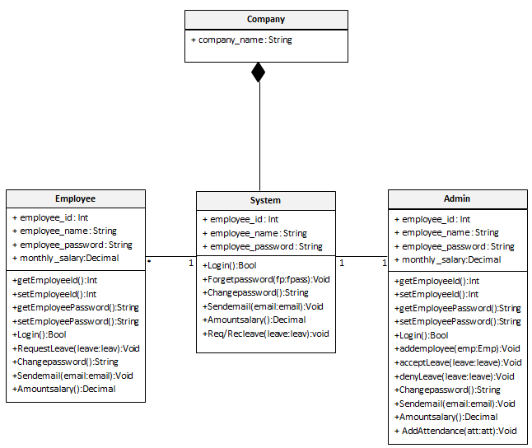

**Figure(1)**

**In Figure(1):**

**Company class:** has company name attribute and the relation between company class and system class are composition.

**System class:** the attributes are the employee name,emp id ,emp password

And has many operation such as: login,forget password,changing password,sending email,

Amount the salary and request/recive leaves.

**Employee class:** has the employee name,emp id ,emp password and monthly salary attributes

And there are many operations such as: 1) Request a leave 2) The daily work schedule in addition to the number of additional hours desired by the employee 3) Inquire about the salary and its value this month 4) Each employee can register with the employee's identification number and password 6)Sending email.

The relation between the system class and the employee class are association.

**Admin or Manager class:** has the employee name,emp id ,emp password and monthly salary attributes. And there are many operations such as: 1) Recive a leave 2) Adding the daily work schedule 3) Inquire about the salary and its value this month 4) The manager can register with the identification number and password 5) Add Employees 6)Sending email.

The relation between the system class and the admin class are association.

**Sequence diagram:**

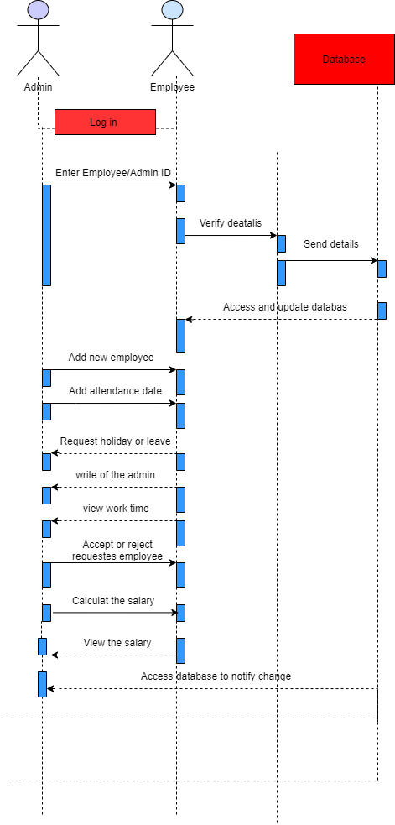

The figure represents a flowchart for the process of using the Personnel Service website.

First, after logging in, the admin adds a new employee, then the employee enters his page and places a vacation or leave that he desires, or talks with the manager and inquires about his working hours or about the salary, and then the manager responds to the inquiries and agrees to the holidays or determines the employees’ salary and their work schedule All this data is stored in a private database.

**ER diagram:**

The ER diagrams describe the entities of the system and shows their attributes and   
  
the relations among them.

The ER diagram of our system is below:  
  
  
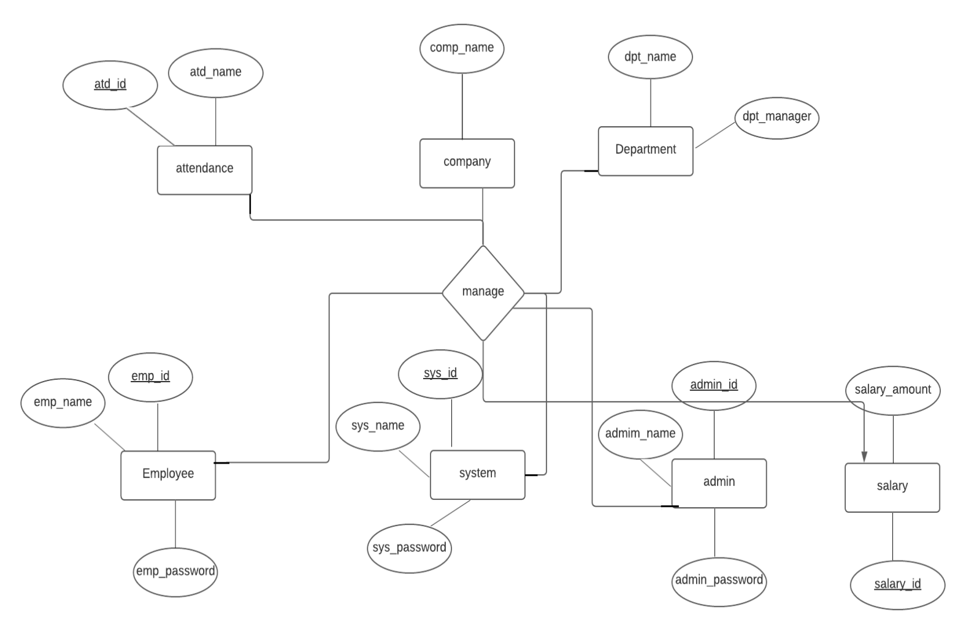

**Human Resource Management System entities and their attributes:**

• **Employee Entity:** Attributes of Employee are employee_id, employee_name, employee_password.

• **System Entity:** Attributes of System are system_id, system_name, system_password.

• **Admin Entity:** Attributes of admin are admin_id, admin_name, admin_password.

• **Salary Entity:** Attributes of salary are salary_id, salary_amount.

• **company Entity:** Attributes of company are company_name .

• **Attendance Entity:** Attributes of attendance are attendance_id, attendance_name.  
• **Department Entity:** Attributes of department are department_name, department_manager.

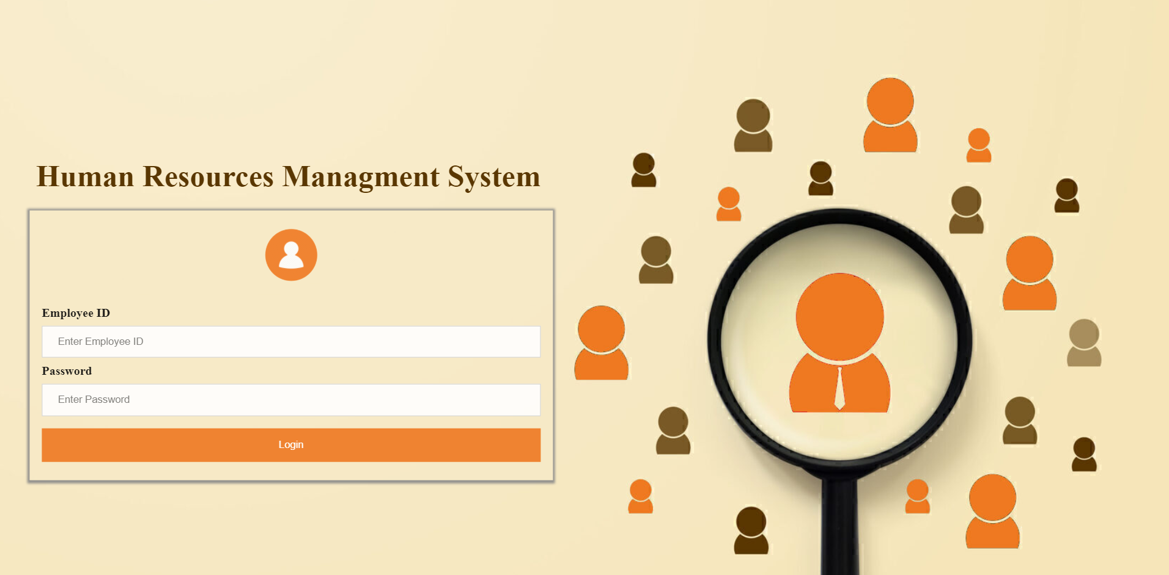**User interfaces design:**

**Figure(1): Login**

On this page, the admin or the user can enter the site using the employee's number and password

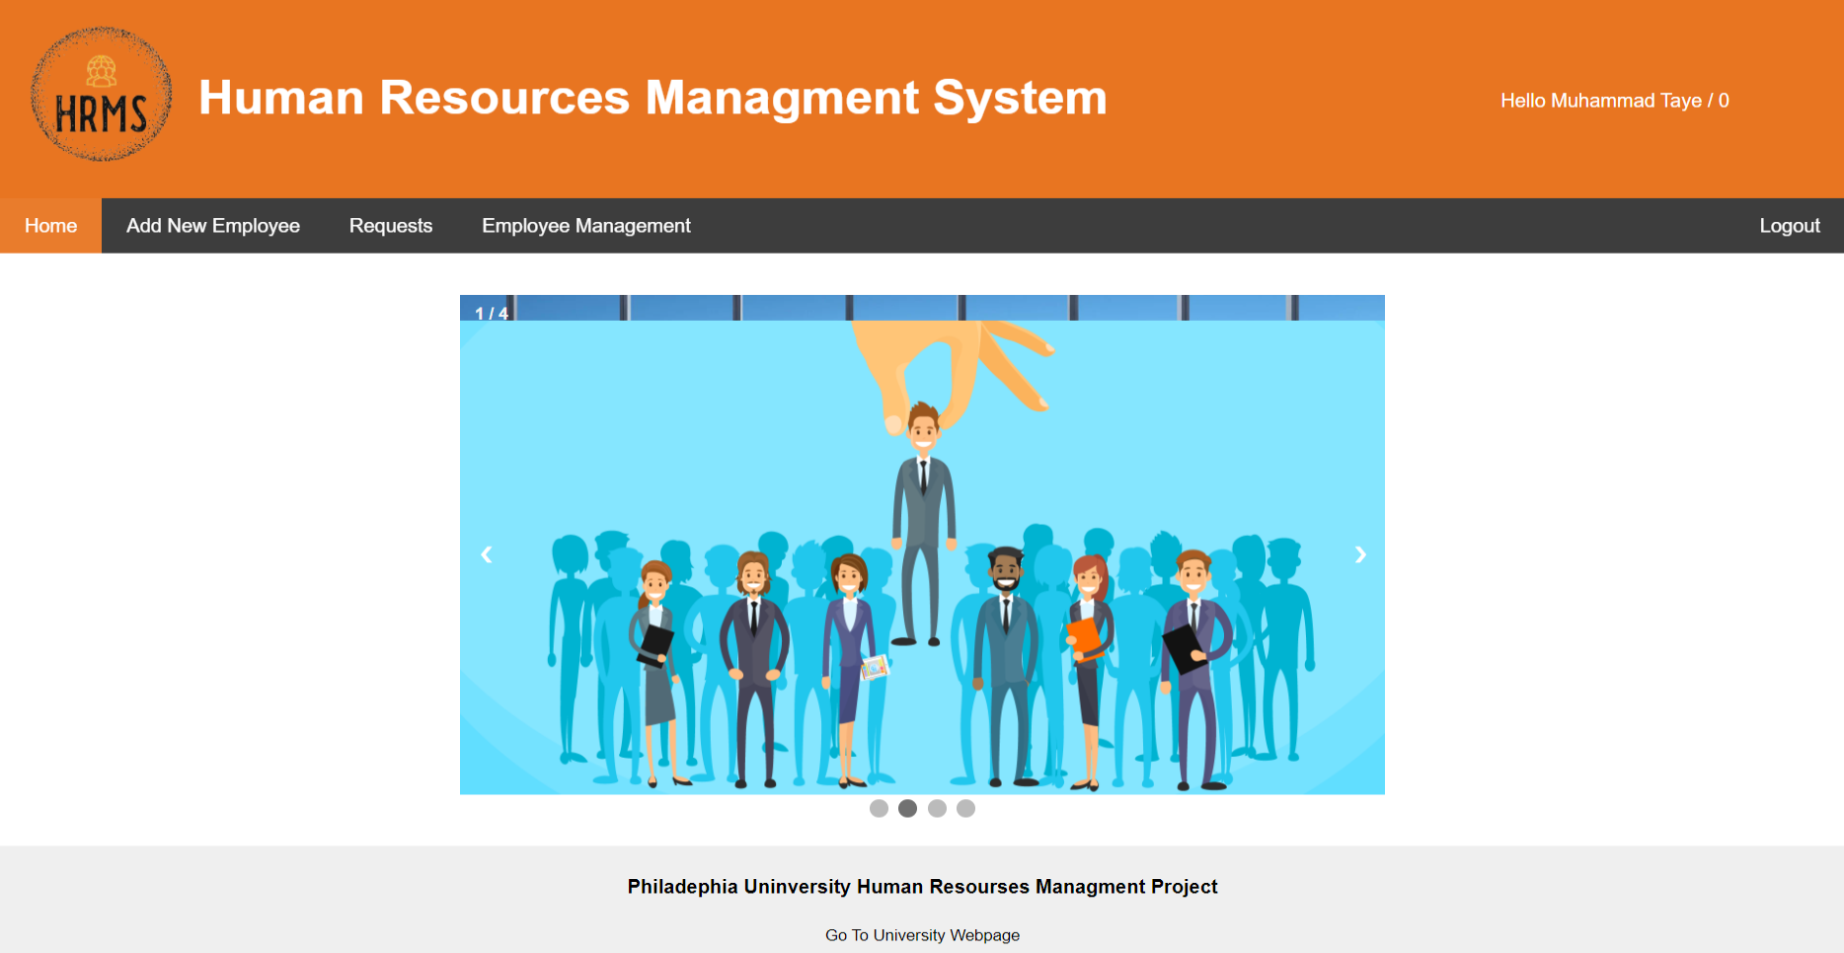

**Figure(2): Home Page Admin**

Home Page is the first and welcome page for the user

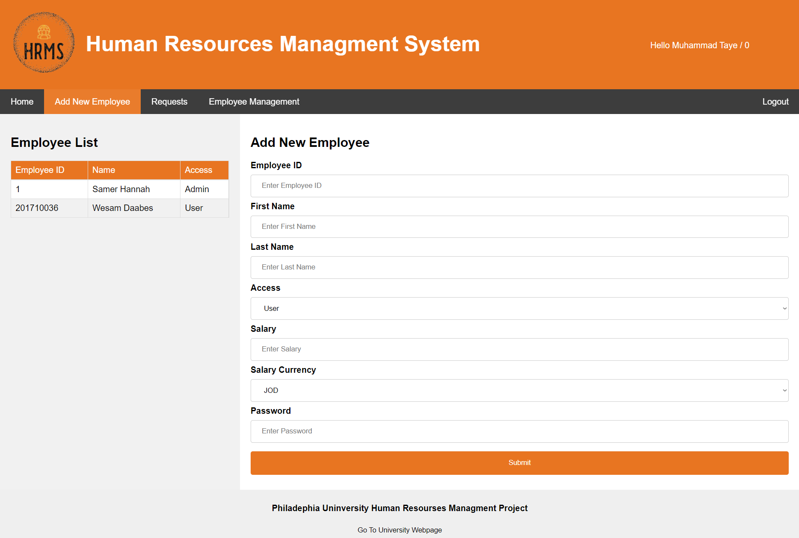

**Figure(3): Add New Employee**

On this page, the admin can add a new employee and determine his salary

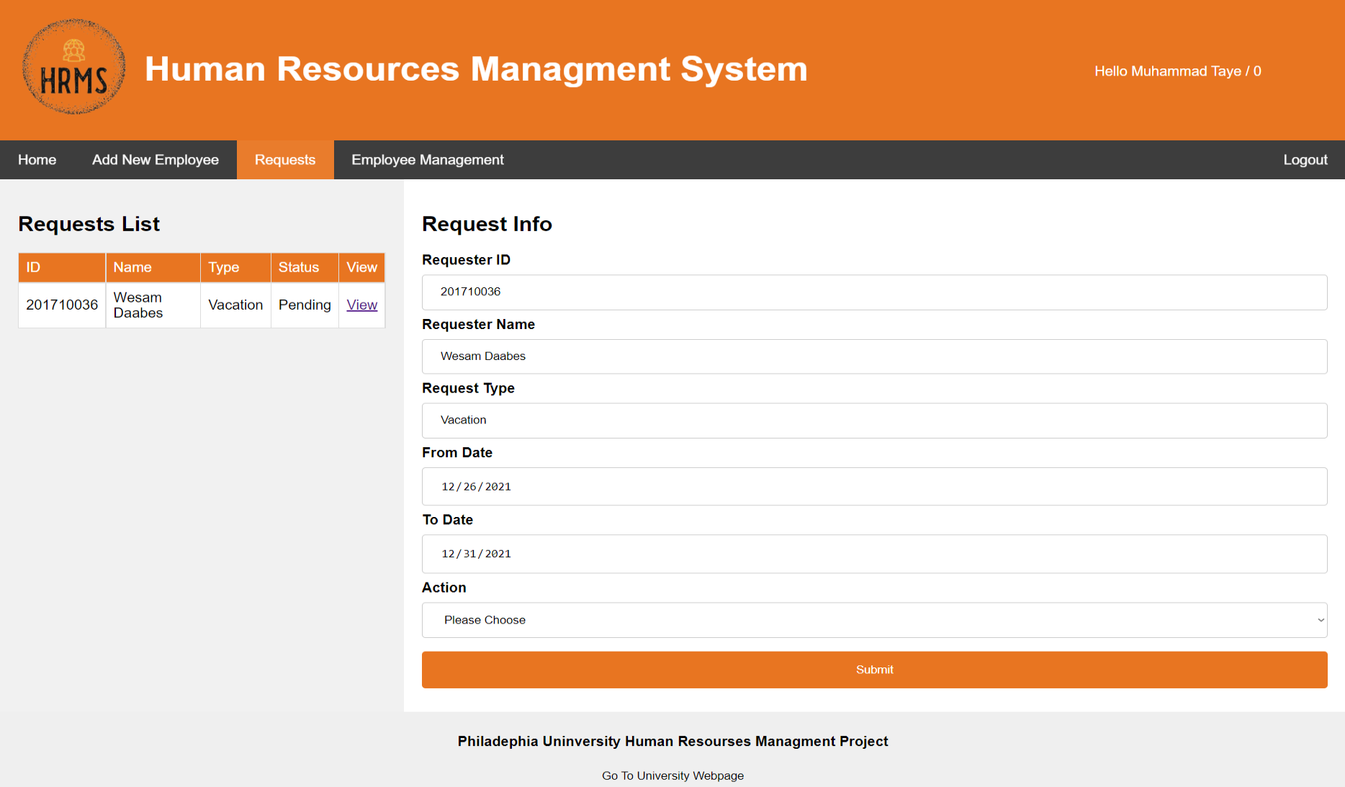

**Figure(4): Requests Admin**

On this page, the admin responds to the vacations or departures provided by the employees by rejecting or accepting

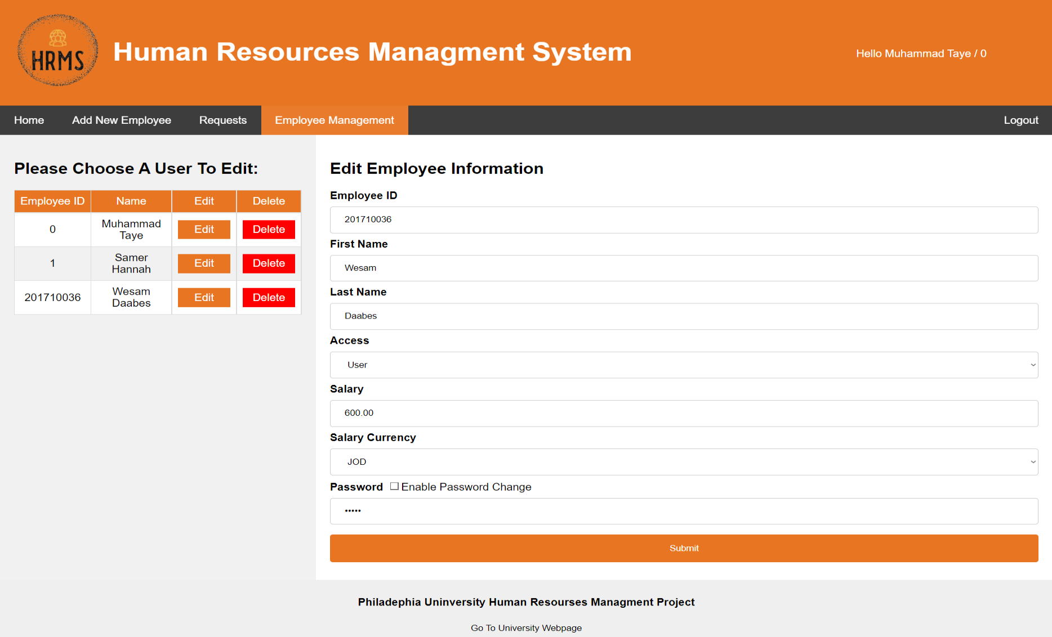

**Figure(5): Employee Management**

On this page, the admin edits employee information or deletes an employee

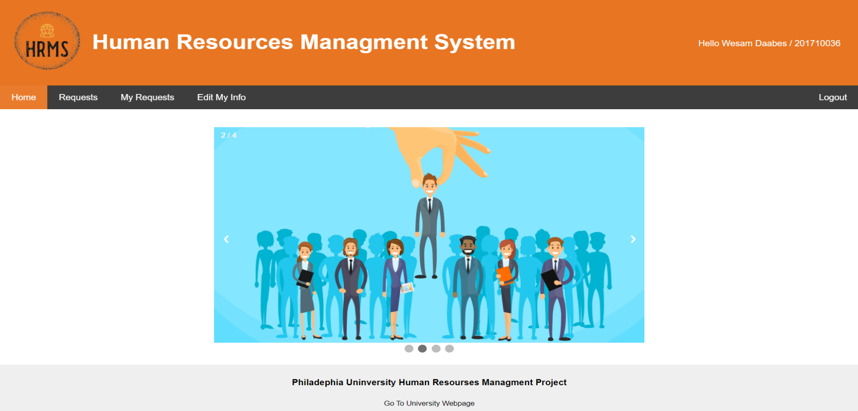

**Figure(6): Home page User**

Home Page is the first and welcome page for the user

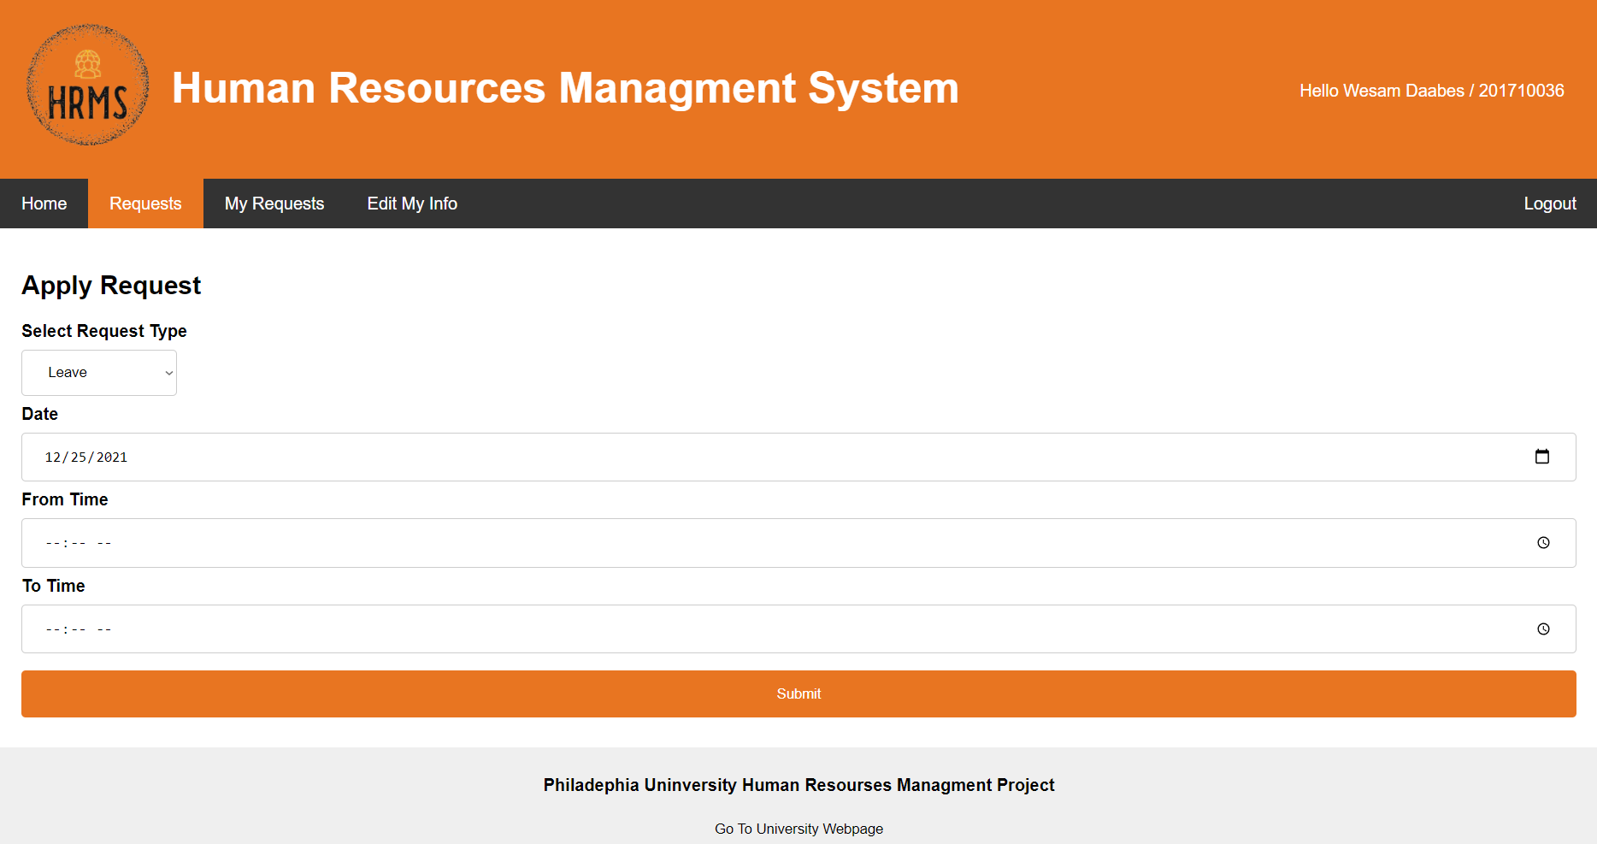

**Figure(7): Requests User**

On this page, the employee submits a leave or leave that he desires, specifying the date and time

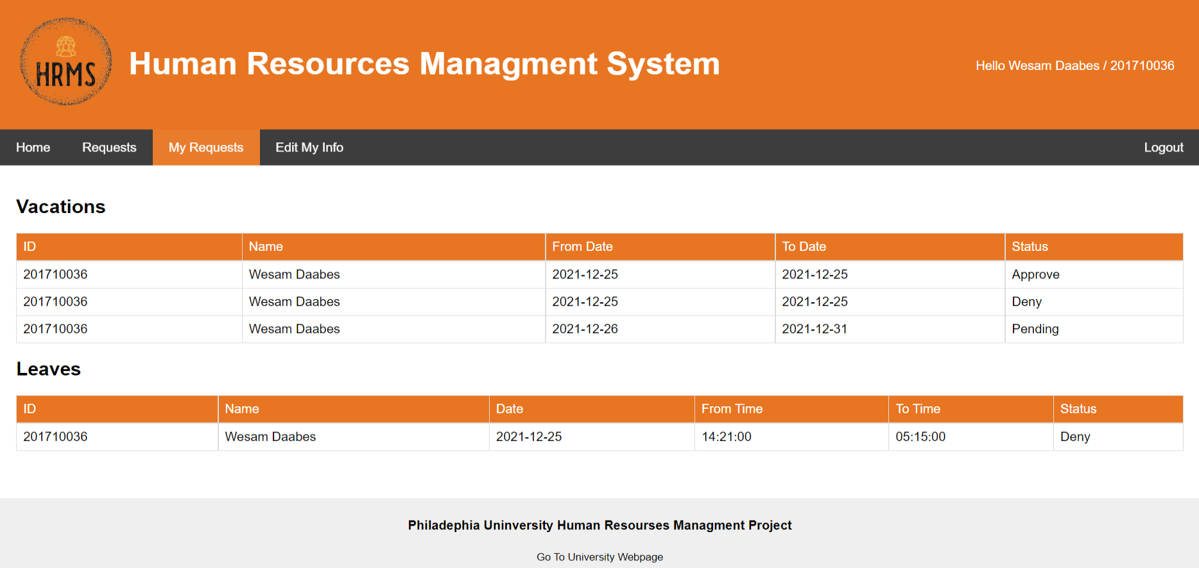

**Figure(8): My Requests**

Here, the employee shows the leaves or departures that he previously submitted and shows that they were accepted or rejected by the admin.

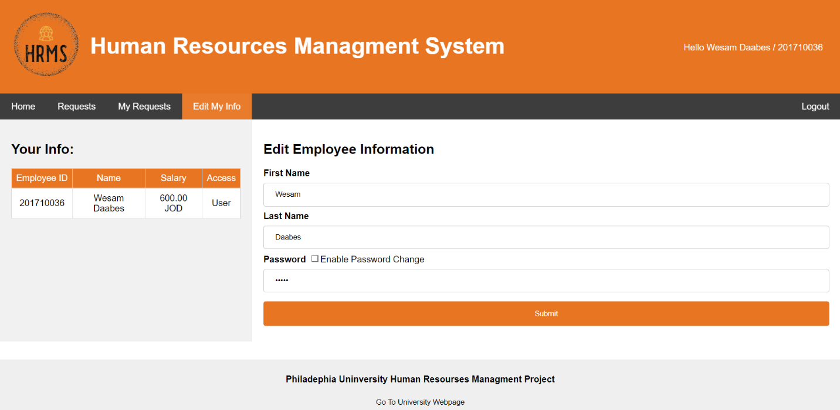

**Figure(9): Edit My Info**

On this page, the employee can modify his name and password